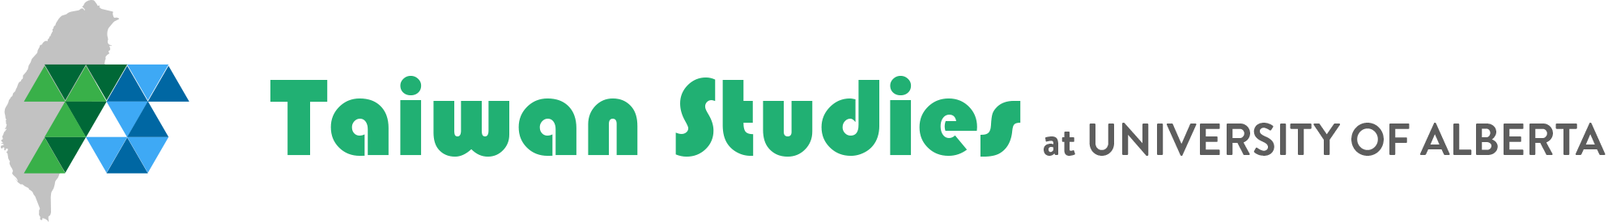
DYNAMICS OF CONTENTION UNDER AUTHORITARIAN REGIMES
May 19-20, 2022
Conventional theories of social movements and civil society have underemphasized the role of social movements in political closed countries. Yet copious evidence exists concerning the power and transformative effects of social movements, including anti-pollution protests in China, prodemocracy activism in Hong Kong, South Korea, and Taiwan, anti-corruption/anti-police brutality demonstrations in Venezuela and Colombia, the anti-apartheid movement in South Africa, and the Arab Spring uprisings. What forms does activism take in authoritarian countries? What strategies have proven more or less effective, as activists seek public support for their causes, policy change, or more lasting effects, including political reform and even regime change?
On May 19-20, 2022, the Taiwan Studies Program at the University of Alberta will host the online workshop “The Dynamics of Political Contention under Authoritarianism.” This workshop aims to address lacunae in existing literature on social movements by soliciting contributions by scholars worldwide.
We invite professional researchers from all disciplines to submit a paper proposal addressing any aspect of social movements, activism, or civil society in non-Western, non-democratic contexts. Accepted participants will present full papers at the workshop (maximum length of 10,000 words).
To submit a paper proposal, please complete the registration form by clicking here. Proposals should include a paper title, brief author bio, and a max 300-word abstract outlining the project’s main argument(s), research methods, and principal evidence and/or findings.
The deadline to submit proposals is February 7, 2022.
Have questions? We would love to hear from you at taiwanst@ualberta.ca
This event is co-sponsored by the Middle Eastern and Islamic Studies Research Group at University of Alberta.

